](https://www.teacherlists.com/)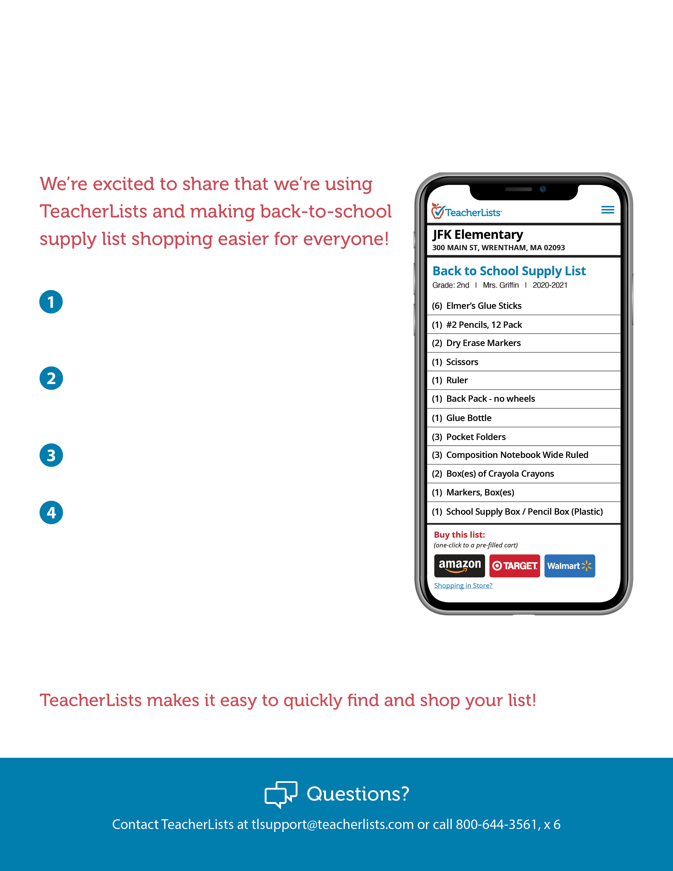

**To all our families at  
(District or School Name):**

To get started, visit our website:

(Insert website URL here)

Click on the link for back-to-school supply lists.   
This will take you to our page on [TeacherLists.com](https://teacherlists.com/)

.

Select your child’s school and list.

Choose how you’d like to shop:

* **One-click online shopping:** Select from major retailers like Amazon, Walmart, Target, (and more!), and your cart is prefilled with the exact items on your list.
* **Shop in store:** Print the lists or use the mobile-friendly checkable list on your phone if you prefer in-store shopping.