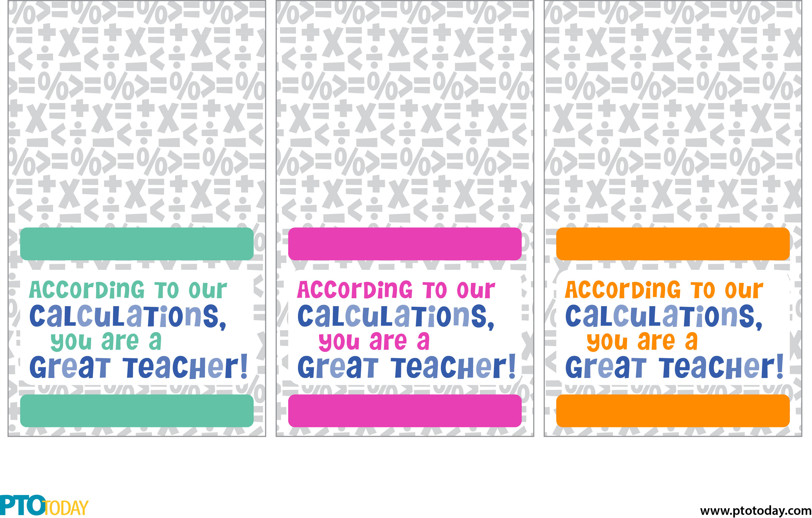

Cut out, fold in half, then staple over the top of the calculator packaging.

Or, cut in half and only use the bottom portion as a tag.

Teacher name here

Your name here

Teacher name here

Your name here

Your name here

Teacher name here