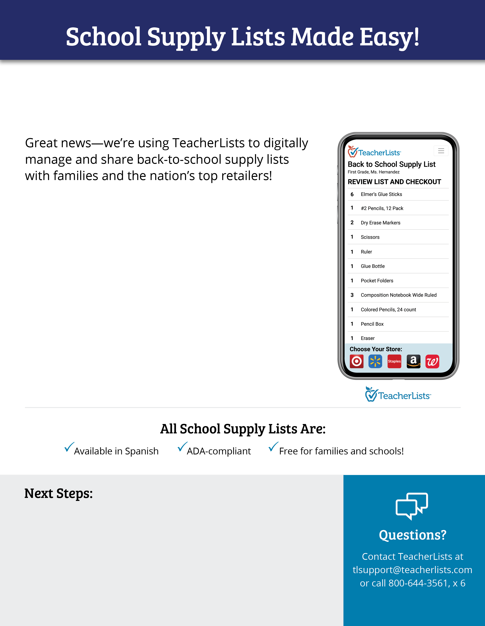

**Efficient for staff:** [Upload](https://app.teacherlists.com/powerloader?utm_source=teacherlists&utm_medium=flyer&utm_campaign=districtflyer_districttoolkit_powerloader_worddoc_textlink_) lists in almost any format such as jpg, pdf, doc,   
and more.

**Easy to share**: Easily add links to school websites, parent portals, social media, email, etc. TeacherLists provides ready-to-use banners and graphics to let families know your lists are ready.

**Instant notification:** [Families can sign up to be notified](https://app.teacherlists.com/list-notifications?utm_source=teacherlists&utm_medium=flyer&utm_campaign=districtflyer_districttoolkit_listnotifications_worddoc_textlink) when lists are posted.

**Automatically sent to retailers:** Supply lists are shared with major retailers, saving you time and distribution hassles.

**One-click shopping:** Online shopping carts are prefilled with the exact list items from national retail partners including Target, Walmart, and more. Families simply select a retailer and check out with one click.

**Shop in store**: Families who prefer in-store shopping can use the checkable list right on their phone.

**To our schools in  
(District or School Name):**

**How to get your lists posted:** Upload your lists at [TeacherLists.com/powerloader](https://www.teacherlists.com/powerloader)

{personalize district instructions here}

**How to share with parents:** Share the link to your lists on your website, social channels, email, etc. TeacherLists has fun banners and graphics you can use at [www.teacherlists.com/share](https://www.teacherlists.com/blog/how-to-share-your-lists-with-parents/). Parents can sign up to be notified when lists are posted.

**How to share with families:** Share the link to your lists on your website, social channels, email, etc. TeacherLists has fun banners and graphics you can use at [TeacherLists.com/share](http://teacherlists.com/share). Families can sign up to be notified when lists are posted.